HOUSEHUNT -

YOUR PERFECT RENTAL HOME

Team Code: LTVIP2025TMID47660
Internship Project Report

INTRODUCTION
HouseHunt is a full-stack rental housing web application designed to streamline the process of searching and booking rental homes. Tenants can easily filter properties based on location, price, and amenities. Landlords can manage listings and bookings, while admins handle user approvals and platform governance.
Built using the MERN Stack (MongoDB, Express.js, React.js, Node.js), the platform offers secure authentication, responsive UI, and real-time data flow for an efficient user experience.

🔹 KEY FEATURES
- 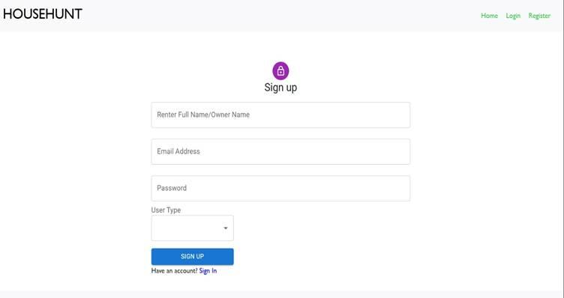
User Registration & Profile Management

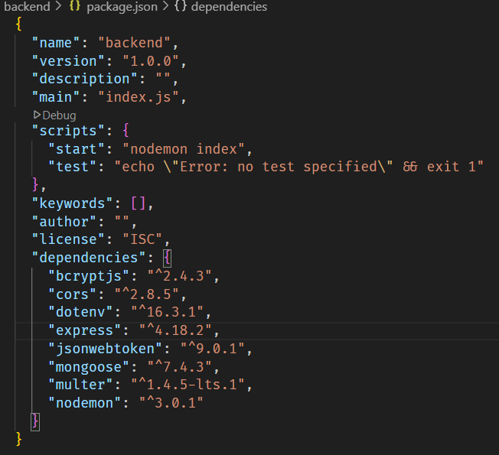
Property Search & Filtering

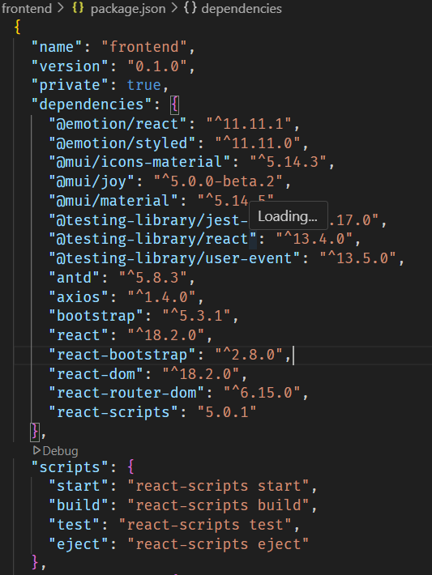

Booking System
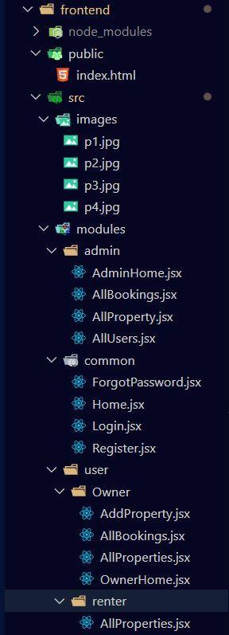

Landlord Dashboard
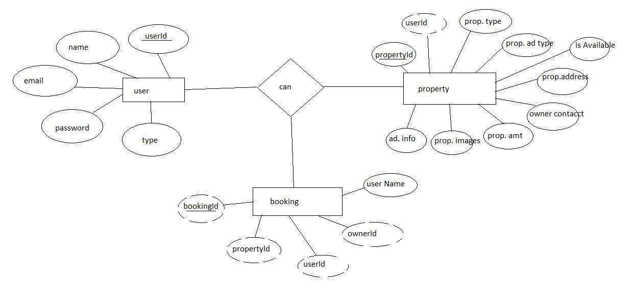
Admin Panel

🔹 TECHNICAL ARCHITECTURE
The system is divided into UI and Backend:
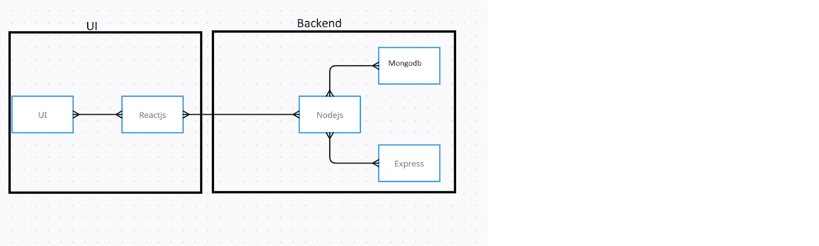
nginx
CopyEdit
UI → ReactJS
Backend → Node.js
→ Express.js
→ MongoDB
This client-server model uses:

🔹 ENTITY RELATIONSHIP DIAGRAM (ERD)

🔹 SCENARIO-BASED CASE STUDY
Registration:
Alice signs up as a renter with email/password.

Browsing Listings:
She filters properties in her city within budget.

Sending Request:
She selects a flat and submits a booking request.

Owner Review:
The owner (Bob) sees the request and approves it.

Admin Role:
Admin ensures Bob is a verified landlord before listing his properties.

Platform Governance:
Admin monitors policy compliance and handles complaints if needed.

Lease Finalization:
Alice and Bob finalize terms via in-app chat and sign agreement.

🔹 PROJECT FOLDER STRUCTURE
🗂️ Backend
pgsql
CopyEdit
backend/
├── config/connect.js
├── controllers/
├── middlewares/
├── routes/
├── schemas/
├── uploads/
├── .env, index.js
🗂️ Frontend
bash
CopyEdit
frontend/
├── public/index.html
├── src/
├── images/
├── modules/admin/
├── modules/user/
├── modules/common/

🔹 DEPENDENCIES
📦 Backend (package.json)
json
CopyEdit
"express", "mongoose", "jsonwebtoken", "bcryptjs", "multer", "cors", "dotenv", "nodemon"
📦 Frontend (package.json)
json
CopyEdit
"react", "axios", "react-router-dom", "antd", "material-ui", "bootstrap", "react-bootstrap"

🔹 SETUP & INSTALLATION

Clone Repo

bash
CopyEdit
git clone <repo-url>

Install Frontend

bash
CopyEdit
cd frontend
npm install
npm start

Install Backend

bash
CopyEdit
cd backend
npm install
npm start
MongoDB SetuP
Use MongoDB Atlas or local Mongo instancE
Set up .env with MONGO_URI and JWT_SECRET

🔹 FEATURES
🖼️ Sign Up Page
User registers as either "Renter" or "Owner" with basic details.
🖼️ Property Listings
Renter dashboard with available properties and filters.
🖼️ Landlord Dashboard
Owner can manage listings and review booking requests.

🔹

🔹 CONCLUSION
HouseHunt offers a complete rental solution using the MERN stack. It streamlines the tenant-landlord connection and provides secure, scalable, and real-time interaction between users. This project fulfills the goals of an efficient and modern rental home management system.

